Chap 2.0: HTML Form
- HTML forms are used to pass data to a server
- A form can contain input elements like text fields, checkboxes, radio-buttons, submit button
- A form can also has the tags: select lists, text area, field set, legend, and label elements
- Syntax: <form>...</form>

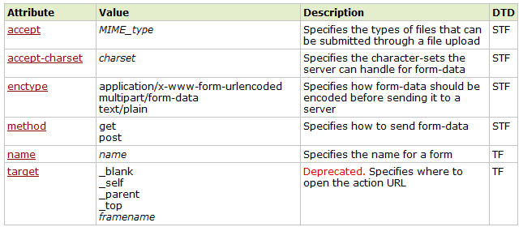

- <input/> tag – The most important form’s element
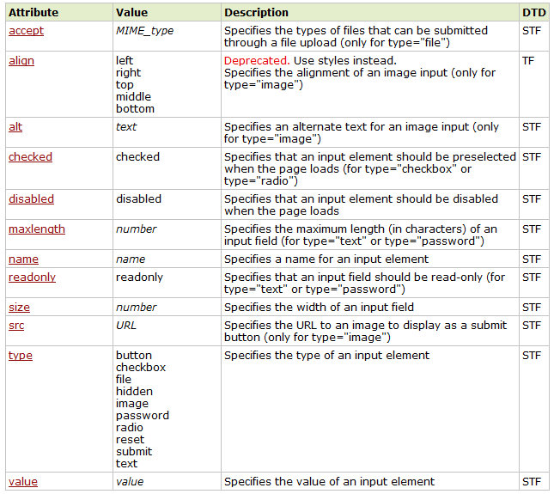

1.1 Text fields
- Defines a one-line input field that a user can enter text into
- Syntax: <input type=”text” name=”...” value=”...” maxlength=”...”/>
  - Each text field should have a unique name

First name: <input type="text" name="firstname"/><br />
Last name: <input type="text" name="lastname" />
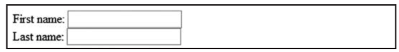
First name: <input type="text" name="FirstName" value="Mickey" /><br />
Last name: <input type="text" name="LastName" value="Mouse" />

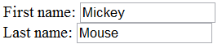

1.2 Password Field
- Defines a password field
- Syntax: <input type=”password” name=”...” value=”...” maxlength=”...”/>
  - Each password field should have a unique name
Password: <input type="password" name="pwd" />
  - The password will be display using ● or *

1.3 Radio Button
- Radio button let users select ONLY ONE of a limited number of choices
- Syntax: <input type=”radio” name=”...” value=”...” checked=”checked”/>
  - All radio buttons must have the same name
  - Each radio button must have a unique value
<input type="radio" name="sex" value="male" checked=”checked”/> Male<br />
<input type="radio" name="sex" value="female" /> Female
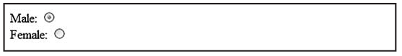

1.4 Check boxes
- Checkboxes let a user select ONE or MORE options of a limited number of choices.
- Syntax: <input type=”checkbox” name=”...” value=”...” checked=”checked”/>
  - All radio button must have the same name
<input type="checkbox" name="vehicle" value="Bike"/> I have a bike<br/>
<input type="checkbox" name="vehicle" value="Car"/> I have a car<br/>
<input type="checkbox" name="vehicle" value="Airplane"/> I have an airplane
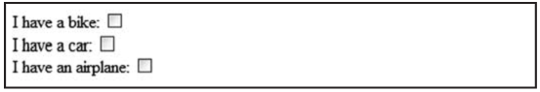
  - Each radio button must have a unique value

1.5 Button
- The <button> tag defines a push button
- Inside a button element you can put content, like text or images
- Always specify the type attribute for the button. The default type for IE is "button", while in other browsers (and W3C specification) is "submit".
- Syntax: <input type=”button” value=”name you want”/>
  - You can change the name of button using value
<input type="button" value="Hello world!">

1.6 Submit button
- A submit button is used to send form data to a server
- Syntax: <input type=”submit” value=”name you want”/>
  - You can change the name of the “Submit” button using value
<input type="text" name="user"/>
<input type="submit" value="Submit"/>

1.7 Reset button
- A reset button is used to clear all the fields and set the form to default
- Syntax: <input type=”reset” value=”name you want”/>
  - You can change the name of the “Submit” button using value
<input type="text" name="user"/>
<input type="reset" value="Reset"/>

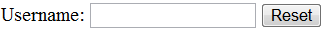

1.8 Image
- Let you display an image in the form
- Syntax: <input type=”image” src=”url to image” name=”...” alt=”...” />
<input type="image" src="http://www.w3schools.com/images/w3cert.gif"/>


1.9 File
- Let users choose a file from their computer and upload them
- Syntax: <input type=”file” name=”...” value=”...” accept=”type of file”/>
<input type="file" value="Choose a file" accept="application/msword">

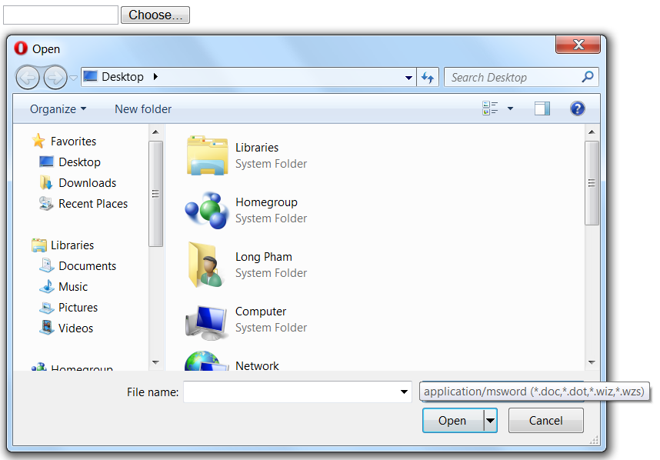

- <Textarea> tag
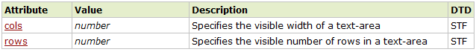
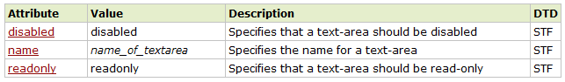
- Defines a multi-line text input control
- A text area can hold an unlimited number of characters, and the text renders in a fixed-width font (default font = Courier)
- Syntax: <textarea> Your text here </textarea>

<textarea rows="10" cols="30"> The cat was playing in the garden. </textarea>
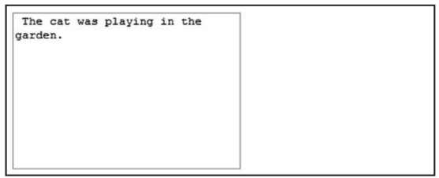

- <Label> tag
- Defines a label for an input element
- The label element does not render as anything special for the user. However, it provides a usability improvement for mouse users, because if the user clicks on the text within the label element, it toggles the control.
- The for attribute of the <label> tag = the id attribute of the related element

<label for="male">Male</label>
<input type="radio" name="sex" id="male"/>
<br/>
<label for="female">Female</label>
<input type="radio" name="sex" id="female"/>

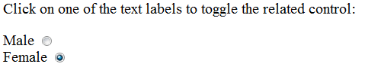

- <Fieldset> tag & <Legend> tag
- The <fieldset> tag is used to logically group together elements in a form. It draws a box around the related form elements
- The <legend> tag defines a caption for the <fieldset> element

<form>
<fieldset>
<legend>Personalia:</legend>
Name: <input type="text" size="30" /><br />
Email: <input type="text" size="30" /><br />
Date of birth: <input type="text" size="10" />
</fieldset>
</form>
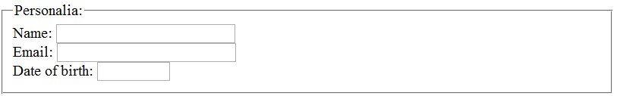

- <select> tag
- The <select> tag is used to create a select list (drop-down list)
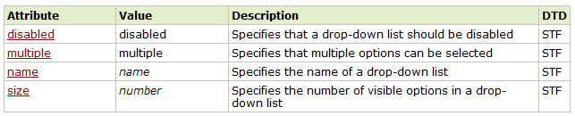

- The <optgroup> tag is used to group together related options in a select list.

- The <option> tags inside the select element define the available options in the list.
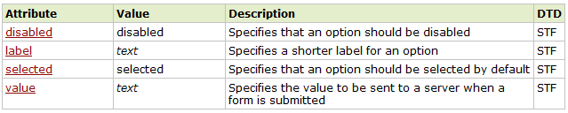
<select>  <option>Volvo</option>  <option>Saab</option>  <option>Mercedes</option>  <option>Audi</option>  </select> | 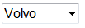 | 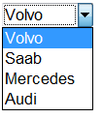
<select>  <option>Volvo</option>  <option>Saab</option>  <option>Mercedes</option>  <option selected>Audi</option>  </select> |  | 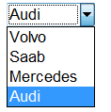
<select>  <optgroup label="Swedish Cars">  <option value="volvo">Volvo</option>  <option value="saab">Saab</option>  </optgroup>  <optgroup label="German Cars">  <option value="mercedes">Mercedes</option>  <option value="audi">Audi</option>  </optgroup>  </select> | 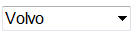 | 